|  |  |  |
| --- | --- | --- |
| HORACE MANN ELEMENTARY SCHOOL  BINGHAMTON - SCHOOL |  |  |
|  |  |  |
| School Detail :- This vision was developed over the course of several months by community members who engaged in a positive and productive dialogue with each other and the district about the preferred future we want for all of our studentsThis vision was developed over the course of several months by community members who engaged in a positive and productive dialogue with each other and the district about the preferred future we want for all of our studentsThis vision was developed over the course of several months by community members who engaged in a positive and productive dialogue with each other and the district about the preferred future we want for all of our studentsThis vision was developed over the course of several months by community members who engaged in a positive and productive dialogue with each other and the district about the preferred future we want for all of our students |  |  |
|  |

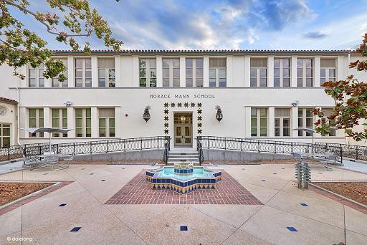

MINIMUM CAPACITY :-

The Minumum intake capacity

of students is between 280-310

children

LIBRARY :-

The Libarary is Available.

CANTEEN:-

The Canteen Facility is Available.

BOARDING :-

No availablility of boarding.

SPORTS :-

There are different categories

sports available.

Girls Volleyball

Boys Volleyball

Football